PROJECT PLANNING PHASE
Project Planning (Product Backlog, Sprint Planning, Stories & Story Points)
Date | 02 October 2026
Team ID | SWTID-2026-9699
Project Name | LegalEase – AI-Powered Legal Document Generator
Maximum Marks | 5 Marks

1. Product Backlog, Sprint Schedule & Estimation
The backlog below decomposes the documented LegalEase scope into user stories. Story points are planning estimates using the 1, 2, 3, 5 scale in the supplied planning-logic document. Sprint allocation is proposed; team member names and actual completion status were not supplied.
Sprint | Functional Requirement (Epic) | User Story No. | User Story / Task | Story Points | Priority | Team Members
Sprint-1 | Setup & Configuration | USN-1 | As a developer, I can configure the project environment and required dependencies so that the application can run. | 2 | High | To be assigned
Sprint-1 | Requirements & Design | USN-2 | As a team, we can define the document-generation flow and request fields so that frontend and backend use a consistent contract. | 2 | High | To be assigned
Sprint-1 | Document Input | USN-3 | As a user, I can select a supported legal document type and enter parties and terms. | 3 | High | To be assigned
Sprint-1 | Backend API | USN-4 | As a user, I can submit document details through the API and receive a structured response. | 3 | High | To be assigned
Sprint-1 | Gemini Integration | USN-5 | As a user, I can request an AI-generated first draft using the details I entered. | 5 | High | To be assigned
Sprint-2 | Draft Review | USN-6 | As a user, I can view and review the generated draft before downloading it. | 2 | High | To be assigned
Sprint-2 | Document Export | USN-7 | As a user, I can download the generated document as TXT, DOCX, or PDF. | 3 | High | To be assigned
Sprint-2 | Input Validation & Errors | USN-8 | As a user, I receive validation feedback for missing required details and an error response if generation fails. | 3 | High | To be assigned
Sprint-2 | Safe Drafting | USN-9 | As a user, I receive a first draft that uses placeholders for missing information and does not claim to be legal advice. | 2 | High | To be assigned
Sprint-2 | Testing & Demonstration | USN-10 | As a team, we can verify the API and export functions and prepare a repeatable application demonstration. | 5 | Medium | To be assigned
Sprint-1 planned total: 15 story points. Sprint-2 planned total: 15 story points. Total planned backlog: 30 story points.

2. Sprint Tracker
The source template includes sprint dates, duration, completed points, and actual release date. Since no approved calendar or execution record was supplied, dates and actual results are left as TBD.
Sprint | Total Story Points | Duration | Sprint Start Date | Sprint End Date (Planned) | Story Points Completed | Sprint Release Date (Actual)
Sprint-1 | 15 | 6 working days | TBD | TBD | Not recorded | TBD
Sprint-2 | 15 | 6 working days | TBD | TBD | Not recorded | TBD

3. Velocity
Velocity is calculated from completed story points divided by the number of completed sprints. The supplied materials do not contain actual completed-sprint results, so actual team velocity cannot yet be calculated. For planning only, the proposed backlog is 30 points across 2 sprints (15 planned points per sprint); this is not measured velocity.

4. Burndown Chart
The chart below is an illustrative planned burndown for Sprint-1 only. It shows a hypothetical reduction from 15 points to 0 across six working days; it is not actual project progress. Replace it with daily remaining-work values from the team tracker during execution.
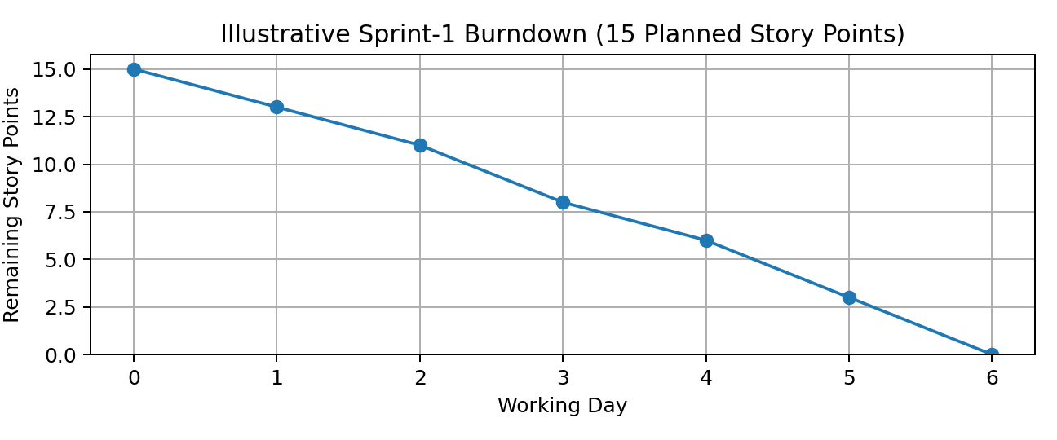

5. Milestones, Dependencies & Risks
- Milestones: environment setup; requirements and design; Gemini integration; document formatting and downloads; testing; documentation and demonstration.
- Dependencies: valid GEMINI_API_KEY and network access are required for Gemini generation. Deployment requires secure secret configuration.
- Risk / limitation: generated legal text is a first draft, not legal advice or a guarantee of legal validity; professional review is required.
- Progress tracking: record owner, status, target date, evidence, and blockers in a project board or spreadsheet. No actual tracker was provided.

Scope & Evidence Note
The backlog is derived from the supplied LegalEase phase documentation and project code: Streamlit input and preview, FastAPI POST /api/generate, Gemini prompt/model integration, and TXT/DOCX/PDF export. Story points, sprint allocation, and the illustrative burndown are planning estimates. Team-member assignments, dates, actual completed points, release dates, and measured velocity must be updated from real project records.

